Neck of pork in spiced plum stock with sweet potatoes

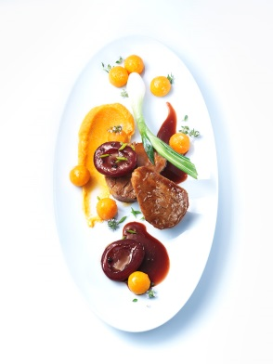
Pork neck:

500 g pork neck
90 g salt
1 g pickling salt to cure the meat
1 liter water
Bring the water to a boil with the two kinds of salt. Allow it to cool, then pour it over the pork, cover it, and brine it for 12 hours.

Remove the pork from the brine and pat dry. Then wrap it tightly in plastic wrap and then in aluminum foil. Fold the ends tightly and simmer at 62°C for 24 hours.
Remove the cooked meat from the water and allow it to cool in ice water. Take the pork out of the foil, pat dry and cut into 2 cm thick slices.

Sweet potato:
1 sweet potato from North Carolina (peeled)
50 g butter
120 ml water
Salt
1 sprig thyme

Use a melon baller to create 10 small 1 cm balls of sweet potato.
In a small pot, melt the butter, add the sweet potato balls and thyme, add the water, bring to a boil, cover and simmer for 20 minutes. Once the sweet potato pearls are cooked through and the water has boiled off, finish with butter.

Mashed sweet potato:

100 g sweet potato (peeled and diced)
Salt
120 ml milk
120 ml cream
110 g butter

Sauté the sweet potatoes in butter, add cream and milk, season with salt and slowly cook sweet potatoes until done. The liquid will not have boiled off completely.
Blend in a mixer and strain through a sieve. Allow to cool down and season to taste.
Spicy plum jus:

10 plums
5 pimento berries
5 peppercorns
4 cloves
8 juniper berries
1 star anise
¼ cinnamon stick
120 ml red wine
80 ml port
5 g Earl Grey tea leaves
4 cl sherry vinegar
200 ml poultry broth
10 g butter
Salt, sugar

Grind the spices and roast in a pan, deglaze with vinegar and add red wine and port. Boil until reduced by half. Add the Earl Grey leaves to the reduction, steep for 5 minutes, strain and let simmer overnight.

To finish the sauce:
Bring the poultry broth to a boil, add reduced spicy plum fond and add the butter. Put plums in hot sauce and season to taste.

For the garnish:
4 spring onions (briefly blanched, sautéed in butter and seasoned)
Sweet potato balls
Preserved plums
Finely chopped chives, mixed with pepper and sea salt

Finishing & serving:
Lightly flour 2 slices of pork for each person and fry gently in canola oil for 2 minutes. Glaze meat with plum jus.
Refine the mashed sweet potatoes with one tablespoon of whipped cream.
Arrange two slices of pork neck with plums and spring onions. Garnish with sweet potato pearls.

