Sweet potato salad with brussels sprouts

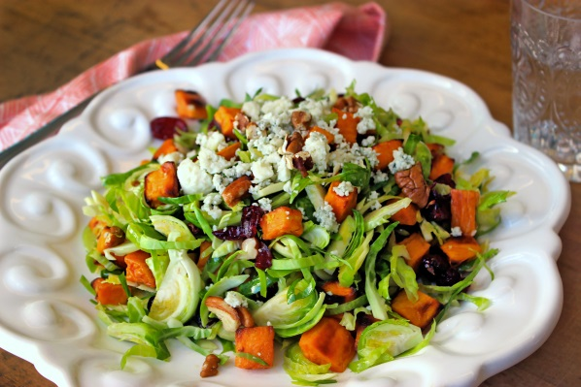
Ingredients (6 servings):

400 g sweet potatoes from North Carolina
3 tablespoons olive oil
600 g Brussels sprouts
2 tablespoons white balsamic vinegar
1 tsp mustard
60 g roasted pecan nuts
50 g dried cranberries
40 g blue cheese
Salt, pepper

1. Preheat oven to 200°C. Peel and dice the sweet potatoes, place on a baking tray and sprinkle with 1 tablespoon olive oil and salt. Bake in the oven for 30 minutes until golden brown, turn occasionally. Allow to cool.

2. Cook the Brussels sprouts in salted water for 15-20 minutes, drain and let cool. Mix the remaining olive oil, balsamic vinegar, mustard, salt and pepper.

3. Halve the Brussels sprouts and cut into slices. Mix with crushed pecans, cranberries and the dressing. Add the sweet potatoes and serve. Sprinkle with cheese.

Preparation time: ca. 50 minutes

Nutrition facts per serving:

Energie260 kcal/1090 kJ
Eiweiß6 g
Fett15 g
Kohlenhydrate24 g

