Sweet potato stir-fry
with chicken breast filets

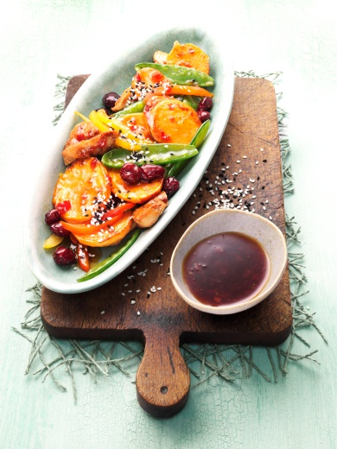
Ingredients for 4 servings:
450 g sweet potatoes from North Carolina
1 chili
20 g ginger
2 cloves garlic
6 tbsp. soy sauce
4 chicken breast filets (à ca. 170 g)
1 red bell pepper
1 yellow bell pepper
200 g sweet peas
1 tbsp. sesame oil
40 g whole, dried cranberries
1 tbsp. light and dark sesame (each)

Directions:

1. Cut chili lengthwise, remove seeds and chop into small pieces. Peel garlic and ginger and chop likewise. Mix chili, garlic and ginger with soy sauce.

2. Wash chicken breast filets, pat dry and cut into bite-sized pieces. Add chicken to the marinade and refrigerate for at least 30 minutes.

3. Meanwhile, peel the sweet potatoes, wash and cut into thin slices. Clean, wash and cut bell peppers into thin strips. Wash sweet peas and halve if necessary.

4. Heat sesame oil in a big frying pan or wok. Remove chicken from marinade, drain and fry in hot oil for approx. 10 minutes until golden brown. Add sweet potatoes and cook until done. Add the remaining vegetable and sauté. Deglaze with marinade, add cranberries and cook for 5 more minutes. Sprinkle with sesame seeds and serve.

Preparation time: ca. 1 hour

Nutrition facts per portion:
Energy: 439 kcal / 1840 kJ
Proteins: 46.8 g
Fat: 8.4 g
Carbohydrates: 42.5 g

