Baked sweet potatoes
with delicious toppings
___________________________________________________________________________

Ingredients for 2 portions:
2 sweet potatoes from North Carolina (250-300 g)

- Preheat the oven to 200 °C (circulating air 180 °C). Wash sweet potatoes, prick with a fork and cook on a baking tray for about 50 minutes.
- Pierce with a fork to test if the sweet potato is well-cooked. Depending on the size of the sweet potato the cooking time may be ca. 10 minutes longer. Then cut open and fill! Serve in parchment paper

Preparation time: ca. 55 Minutes

Guacamole with shrimps

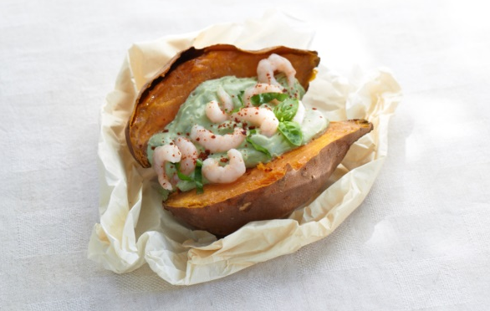
Ingredients for 2 portions:
2 stems basil
Pulp of 1 avocado
3 tbsp orange juice
2 tbsp sour cream
100 g shrimps
Salt, pepper

- Wash and shake basil dry, pluck the leaves and cut 3-4 pieces into small strips. Put aside as garnish.
- Blend avocado pulp with 1 tbsp orange juice and the remaining basil, then season with salt and pepper.
- Mix the shrimps with the remaining orange juice, some salt and pepper.
- Slice sweet potatoes in half, top with avocado cream and garnish with shrimps and basil.

Preparation time: 15 Minutes

Nutrition facts per portion:
Energy: 512 kcal
Protein: 15 g
Fat: 19,5 g
Carbohydrates: 67,4 g

Zucchini-tzatziki with sesame chicken

Ingredients for 2 portions:
1 zucchini (ca. 200 g)
1 chicken breast fillet (ca. 150 g), in slices
½ tsp tumeric powder
2 tbsp sesame seeds
1 tbsp rapeseed oil
1 garlic clove, finely chopped
200 g yoghurt
1 tsp Wasabi
Salt, pepper
Chive

- Wash zucchini and slice into thin strips. Salt and pepper the chicken breast, then turn the strips in sesame seeds and turmeric and fry in a pan for 4-5 minutes.
- Mix the zucchini strips with garlic, yoghurt and wasabi, season with salt and pepper. Spread the tzatziki over the sweet potatoes. Garnish with chicken strips and chive.

Preparation time: ca. 25 Minutes

Nutrition facts per portion:
Energy: 531 kcal
Protein: 29,2 g
Fat: 14,8 g
Carbohydrates: 67,6 g

Tomato-mango-salsa

Ingredients for 2 portions:
1 small red onion
200 g cherry tomatoes, quartered
1 mango, in cubes
1 tbsp red wine vinegar
1 tbsp olive oil
75 g low-fat feta cheese in cubes
Salt, pepper

- Peel onion, cut into halves, then into small slices. Mix with tomatoes, mango cubes, whisk together vinegar and oil, add salt and pepper.
- Arrange sweet potatoes and garnish with feta on top.

Variation: chop 1 tsp capers and mix with the salsa.

Preparation time: ca. 15 Minutes

Nutrition facts per portion:
Energy: 531 kcal
Protein: 15,3 g
Fat: 10,2 g
Carbohydrates: 88,6 g

Olive-Hummus

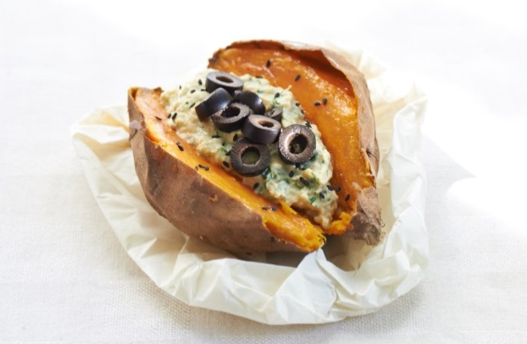
Ingredients for 2 portions:
½ Bund parsley
120 g chickpeas (1/2 can), drained
3 tbsp yoghurt
1 tsp lime juice
Salt, pepper
1-2 tsp black cumin
40 g sliced black olives

- Wash parsley and shake dry, pluck the leaves and blend with chickpeas, yoghurt, lime juice, salt and pepper.
- Spread the puree over the sliced sweet potato and garnish with black cumin and olives.

Preparation time: ca. 10 Minutes

Nutrition facts per portion:
Energy: 352 kcal
Protein: 7 g
Fat: 6,1 g
Carbohydrates: 65 g

