Festive sweet potato au gratin

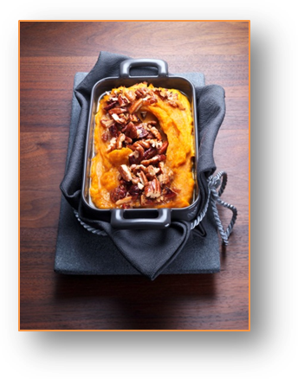

Ingredients for 4 servings:
1 kg sweet potatoes from North Carolina
250 ml milk
60 g butter
1 egg (middle-sized)
120 g soft sugar
1 pack vanilla sugar
½ tsp. powdered cinnamon
100 g pecans

1. Peel and wash sweet potatoes, cut into cubes and boil them in a pot for 20 minutes. In the meantime, heat milk, whisk the egg and melt butter. Drain sweet potatoes and mash them. Add whisked egg, 100 g soft sugar, vanilla sugar, 40 g melted butter and cinnamon. Then add the milk while stirring constantly.

2. Fill mass into a greased casserole. Chop pecans roughly and spread evenly over mass. Top with remaining soft sugar and remaining butter. Bake for 30 minutes in the preheated oven (electric oven: 200 ° C/ convection oven: 175 °C/ gas: 3rd degree).

Preparation time: approx. 1 hour

Nutrition value per serving:
Energy: 742 kcal / 3106.5 kJ
Protein: 10.4 g
Fat: 35.65 g
Carbohydrates: 93.9 g

