Scallops with sweet potato royale, barberry and cauliflower

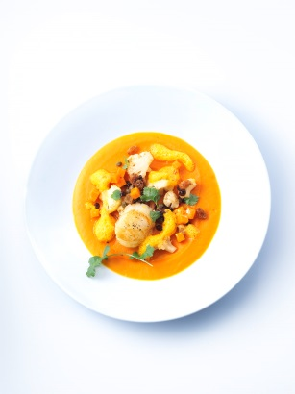
For the sweet potato foam:
300 g sweet potatoes from North Carolina
1 liter poultry broth
300 g crème double
100 g crème fraîche
100 ml white Port
100 ml Noilly Prat
40 g butter
Salt, lemon, Cayenne pepper

Wash, peel and cut the sweet potatoes. Cook in poultry broth until tender. Puree with crème double and crème fraîche and strain through a fine sieve. Reduce the white port and Noilly Prat and add to the crème. Boil up, flavor and stir in butter flakes.

Royal
2 eggs
1 egg yolk
600 g sweet potato foam
Salt, Cayenne pepper

Mix 600 g of sweet potato foam with eggs and egg yolk. Put into 4 big soup bowls and cover with foil. Let it set at 85 °C for 40 minutes.

Scallops
4 Scallops
2 Leaves of brick pastry
1 liter olive oil
Salt, fresh grounded pepper, lemon juice

Cut brick into strips, season scallops and wrap in brick strips. Let dry for a short time and fry in olive oil until it is crisp and brown.

Sweet potatoes
2-3 Sweet potatoes (washed, peeled and diced)
30 g raisins
20 g barberries
20 g capers
200 g cauliflower (cleaned and cut in small slices)
40 g butter
2 tbsp. olive oil
2 cl Burgundy vinegar
200 ml poultry broth
Salt, fresh grounded white pepper
1 tbsp. cilantro finely chopped

Sauté sweet potatoes in olive oil, deglaze with Burgundy vinegar and reduce. Pour on poultry broth, cover and steam slowly. Add raisins, barberries and capers and season to taste.

Add some olive oil and put aside. Fold in barberries under the warm sauce.

Fry thin slices of cauliflower slowly until brown, season with salt and pepper and add cilantro.

Serving:
Place sweet potatoes, scallops and cauliflower on the Royal and serve with the rest of the sweet potato foam.

